**DAILY ONLINE ACTIVITIES SUMMARY**

|  |  |  |  |
| --- | --- | --- | --- |
| **Date:** | 29/06/2020 | **Name:** | Krishnitha |
| **Sem & Sec** | 4th sem, A Section | **USN:** | 4AL18CS039 |
| **Online Test Summary** | | | |
| **Subject** | NA | | |
| **Max. Marks** | NA | **Score** | NA |
| **Certification Course Summary** | | | |
| **Course** | DevOps Engineer | | |
| **Certificate Provider** | AWS Educate | **Duration:** | 4 hrs |
| **Coding Challenges** | | | |
| **Problem Statement:**  Given a list of numbers, write a Python program to count Even and Odd numbers in a List. | | | |
| **Status:** Executed | | | |
| **Uploaded the report in GitHub** | | YES | |
| **If yes Repository name** | | <https://github.com/krishnitha/Python-coding> | |
| **Uploaded the report in slack** | | YES | |

**Certification Course Details:**

Today I have continued the course “DevOps Engineer” by AWS Educate. In this course today I learnt about ‘Programming and Scripting’. Today I have completed two modules of this course, And I have also completed the assessment of this module.

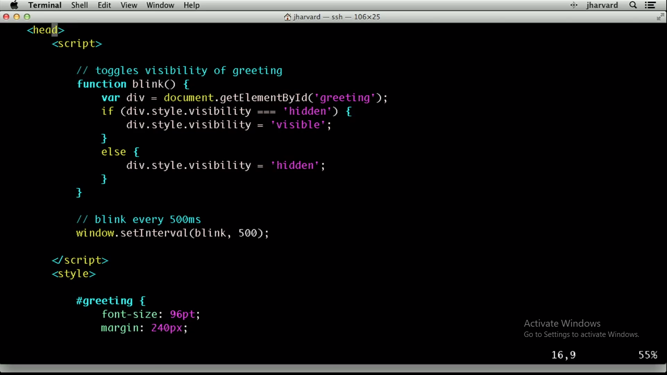

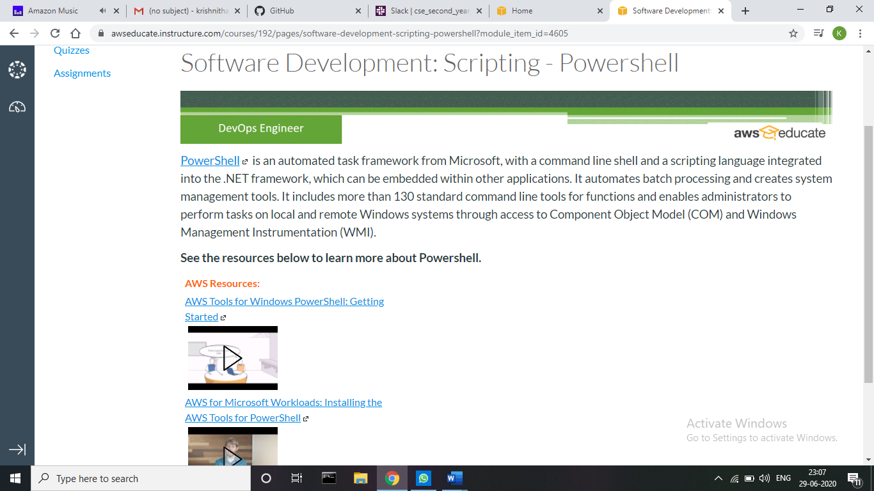

**Webinar Details:**

Today I have attended the webinar on “Cyber Security &amp; Applications” by Professor Dr. Manjunath Kotari, HOD CSE department- AIET. The session was very interesting. There were two assessments conducted based on the webinar. The tests were of MCQ type.

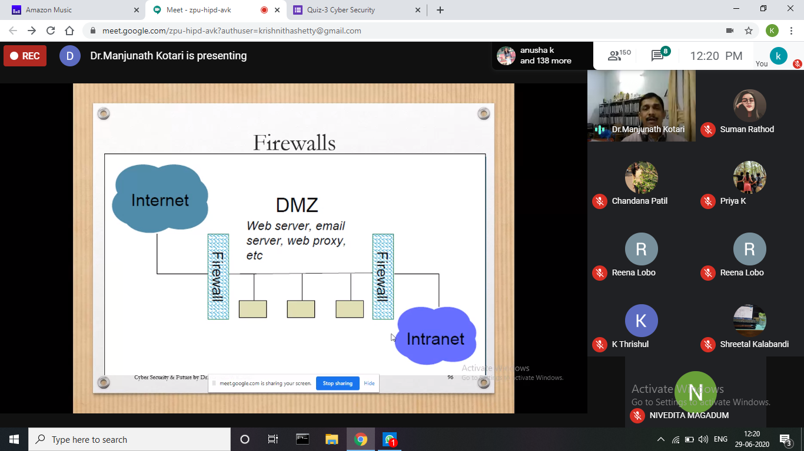

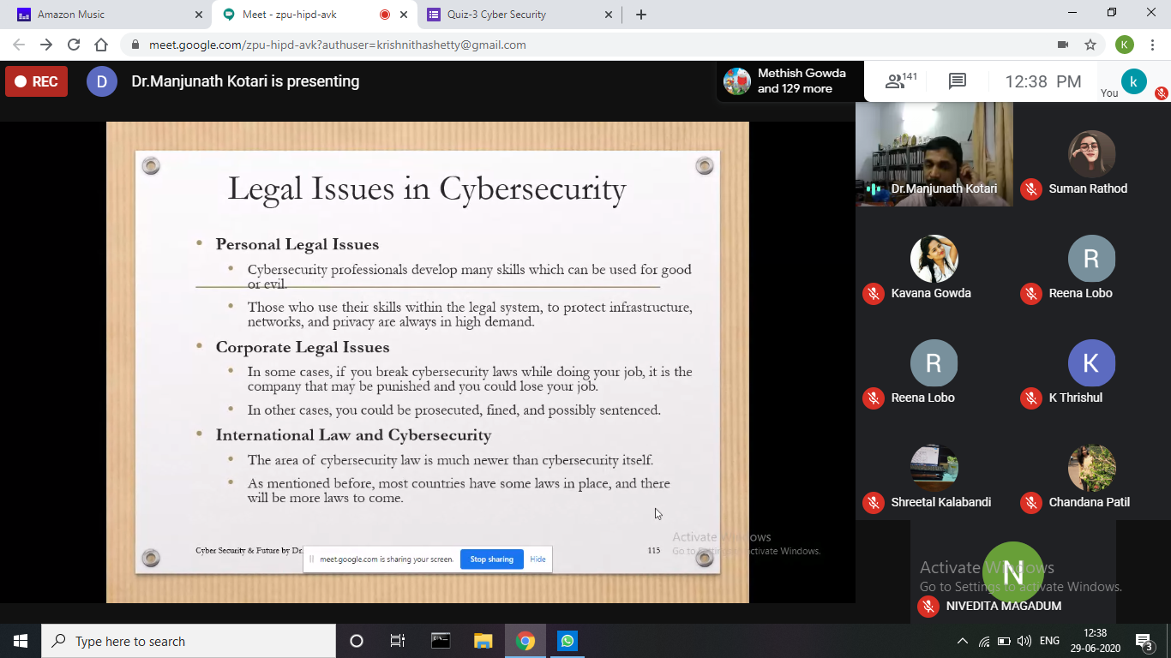

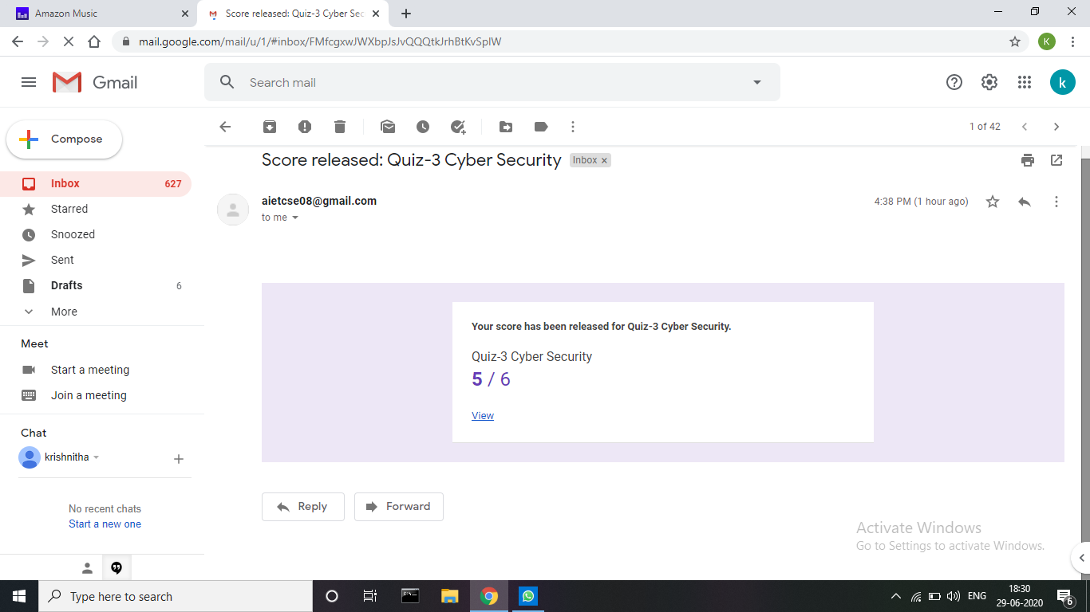

**Coding Challenges Details:**

**Problem 1:** Given a list of numbers, write a Python program to count Even and Odd numbers in a List.

**Example:**

Input: list1 = [2, 7, 5, 64, 14]

Output: Even = 3, odd = 2

Input: list2 = [12, 14, 95, 3]

Output: Even = 2, odd = 2

Example 1: count Even and Odd numbers from given list using for loop Iterate each element in the list using for loop and check if num % 2 == 0, the condition to check even numbers. If the condition satisfies, then increase even count else increase odd count.

**Solution:** Uploaded it in GitHub

